1. No indication of error  
   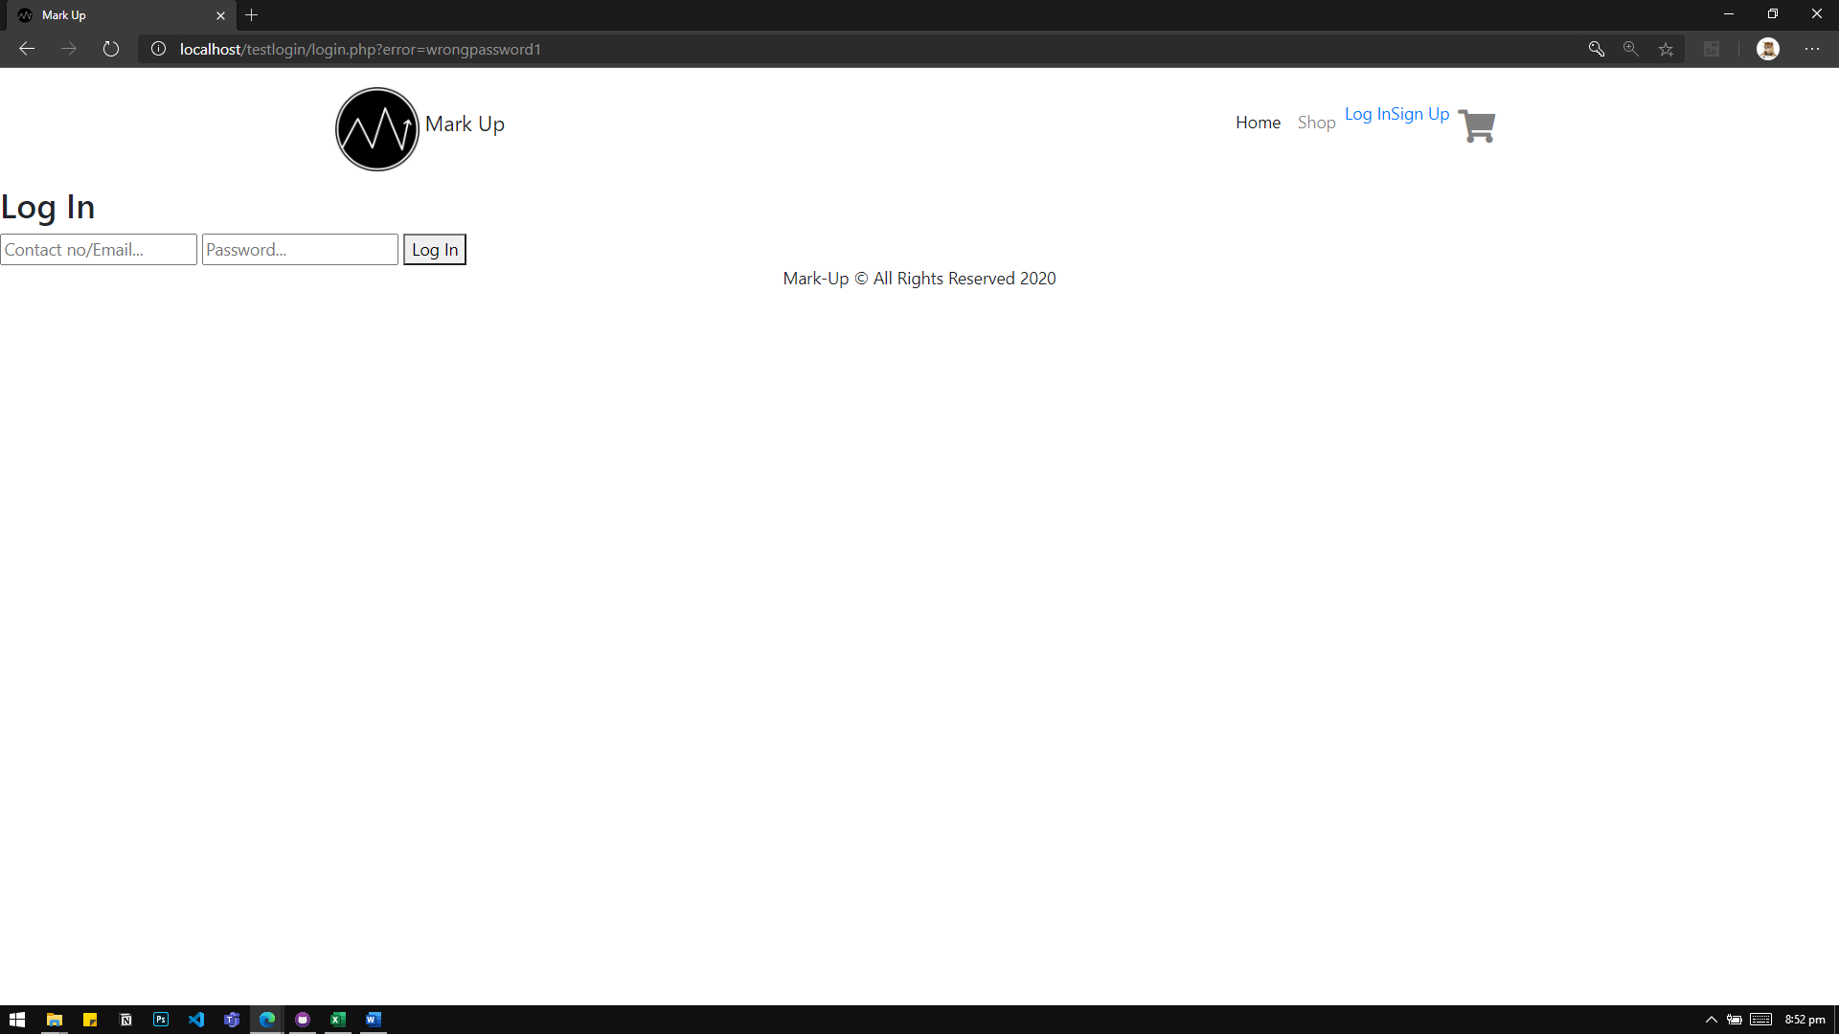

Here, I entered test3 (not registered user), and a random password. There is no indication if I entered wrong password or email here.

1. Logging in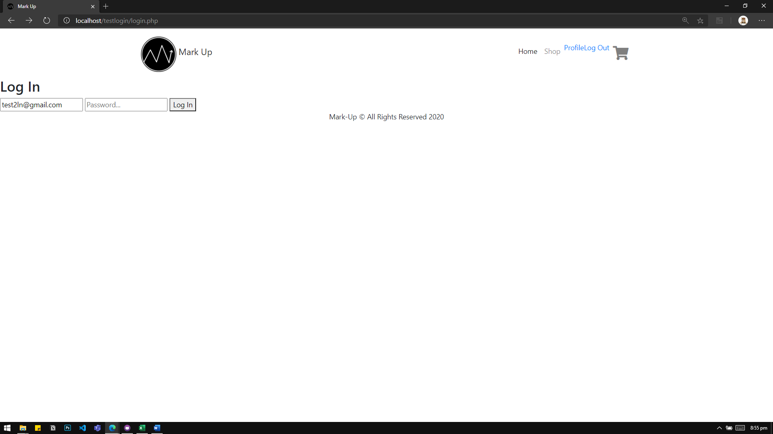

Once logged in, I can still go back and go in login page to login in another account.

I think you can refer here: <https://stackoverflow.com/questions/50712560/how-to-prevent-a-php-page-from-browser-back-button>

1. In signing up, I can input a number with less than 11 digits, also, not starting in 09

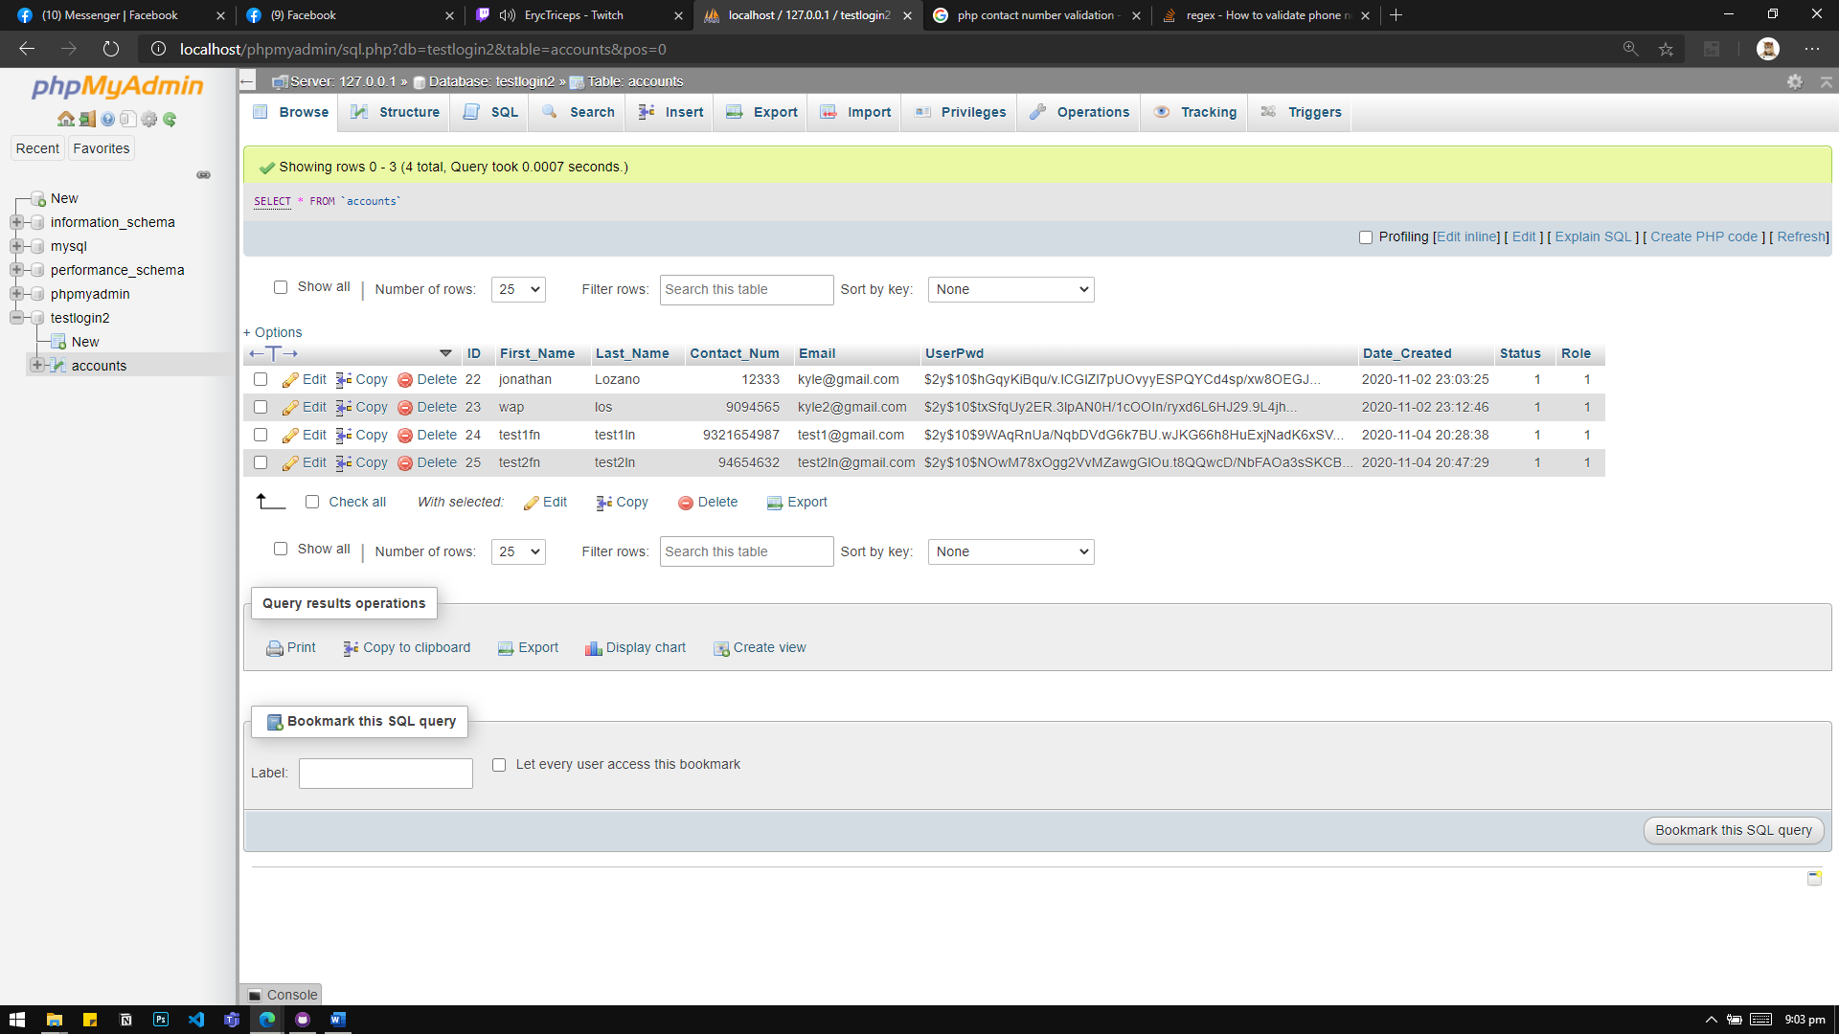

I think you can refer here: <https://stackoverflow.com/questions/3090862/how-to-validate-phone-number-using-php>

1. While logged in, I think we need to display the first name of the user

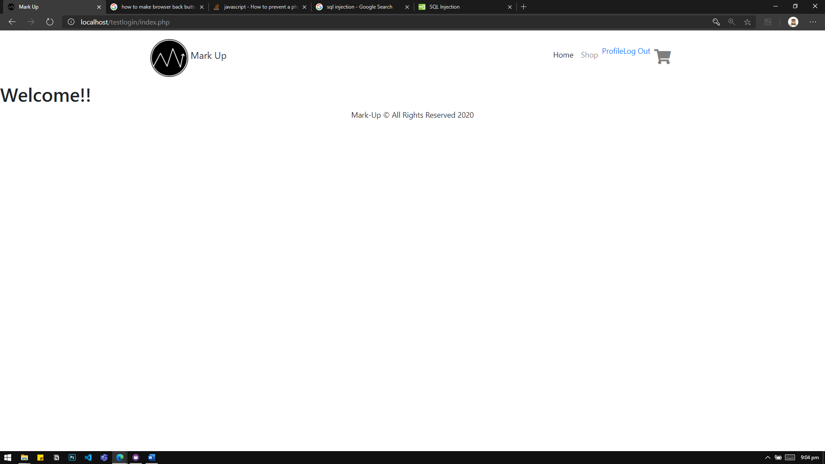  
  
I think you can refer here: <https://stackoverflow.com/questions/20654848/html-php-display-username-after-success-login>